J COMPONENT REVIEW -1 DOCUMENT

NAME – ADITYA DEWANI
REG NO – 16BCE2319
SLOT-C2

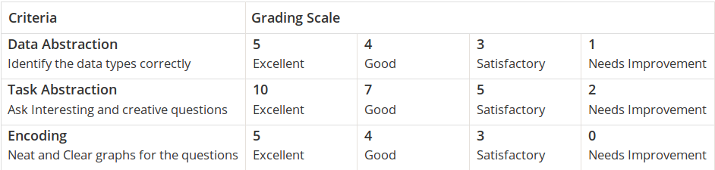

DATASET :

Fifa world cup data from 1930 to 2014

WorldCups.csv
WorldCupMatches.csv
WorldCupPlayers.csv

DATA ABSTRACTION ( Reduction of dataset to useful data set )

# taking dataset into variables :

matches = pd.read_csv(r"WorldCupMatches.csv")

cups = pd.read_csv(r"WorldCups.csv")
# calculating null values :
matches.isnull().sum()
# setting the style of plots :
sns.set_style("darkgrid")
# removing duplicate rows for match id coloumn :
matches = matches.drop_duplicates(subset="MatchID",keep="first")

# removing null values :

matches = matches[matches["Year"].notnull()]
# using only the coloumns that are needed and removing the other coloumns :
new_matches=pd.read_csv("WorldCupMatches.csv", usecols=['Year','Datetime','Stadium','City','Home Team Name','Home Team Goals','Away Team Goals','Away Team Name','Attendance','MatchID','Home Team Initials','Away Team Initials'])
# no data abstraction in WorlsCups dataset as all the coloumns are nessesary and all rows have values

# WorlsCupPlayers Dataset
# reading dataset into variables :
players= pd.read_csv("WorldCupPlayers.csv")
# using only the necessary coloumns :
new_players=pd.read_csv("WorldCupPlayers.csv", usecols= ['Team Initials','Coach Name','Player Name','Position'])

TASK ABSTARCION :
The main task of this project is to visualise and interpret the dataset of fotball worldcup from 1930 to 2014 and hence deduce the change in trends of various attributes .

